

**Day 1:** Library (8:55-9:40)

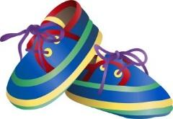

**Day 1:** Gym (2:10- 2:55)

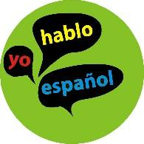

**Day 2:** Spanish (2:10 – 2:55)

**Day 3:** Gym (12:25 – 1:15)

**Day 4:** No special



**Day 5:** Art (8:55- 9:40)

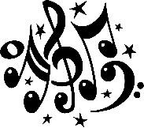

**Day 6:** Music (2:10 –2:55)